**Commodore VIC-20 Diagnostic User Port PCB Rev. 1**

**Module Description**

Table of content

Connectors 2

User Port 2

IEC-Bus 2

Cassette Port 2

Control Port 2

Feedbacks 3

User Port (J1) 3

IEC-Bus (J2) 3

Cassette Port (J3) 3

Control Port (J4) 3

Note 3

3D-printed Case 3

Revision History 4

Rev. 0 4

Rev. 1 4

The VIC-20 Diagnostics User Port PCB provides most of the required feedbacks for the Commodore Diagnostic Software. Those are the feedbacks for the User Port, the IEC (serial) bus and the Cassette Port. Only the keyboard feedbacks are realized on the Diagnostic Keyboard PCB.

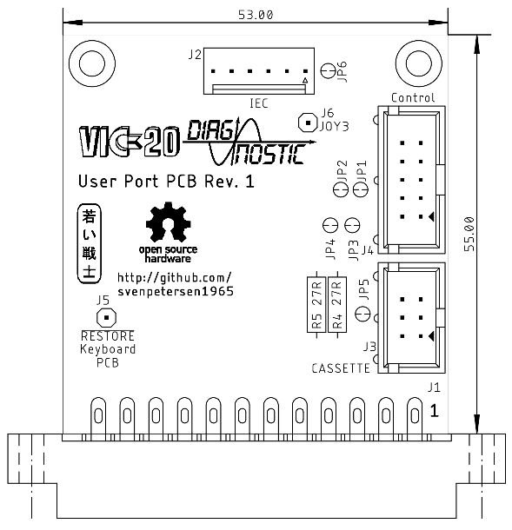

Figure 1: Dimensions of the User Port PCB

# Connectors

## User Port

J1- Edge Connector (2x12, 3.96mm pitch)

|  |  |  |  |
| --- | --- | --- | --- |
| **Pin** | **Signal** | **Pin** | **Signal** |
| 1 | GND | A | GND |
| 2 | +5V | B | CB1 |
| 3 | /RESET | C | PB0 |
| 4 | JOY0 | D | PB1 |
| 5 | JOY1 | E | PB2 |
| 6 | JOY2 | F | PB3 |
| 7 | LIGHTPEN | H | PB4 |
| 8 | CASSSW | J | PB5 |
| 9 | ATN | K | PB6 |
| 10 | 9VAC(1) | L | PB7 |
| 11 | 9VAC(2) | M | CB2 |
| 12 | GND | N | GND |

## IEC-Bus

J2 – KF2510, 6pin (compatible to Molex KK 254 series, 6p. - P/N 22272061)

|  |  |  |
| --- | --- | --- |
| Pin | Signal | DIN 6 |
| 1 | SQR IN | 1 |
| 2 | GND | 2 |
| 3 | ATN | 3 |
| 4 | CLK | 4 |
| 5 | DATA | 5 |
| 6 | n.c | - |

## Cassette Port

J3 – 2x3 pin header for a ribbon cable connected to the cassette port PCB (project number 114, from the C64 Diagnostic Harness).

|  |  |  |  |
| --- | --- | --- | --- |
| **Pin** | **Signal** | **Pin** | **Signal** |
| 1 | GND | 2 | n.c. |
| 3 | MOTOR | 4 | READ |
| 5 | WRITE | 6 | SENSE |

## Control Port

J4 – 2x5 pin header for a ribbon cable which connects via a D-SUB 9 (female) to the control port.

|  |  |  |  |  |  |
| --- | --- | --- | --- | --- | --- |
| **Pin** | D-SUB | **Signal** | **Pin** | D-SUB | **Signal** |
| 1 | 1 | JOY0 (up) | 2 | 6 | LIGHTPEN |
| 3 | 2 | JOY1 (down) | 4 | 7 | +5VCTR1 |
| 5 | 3 | JOY2 (left) | 6 | 8 | n.c. (GND) |
| 7 | 4 | JOY3 (right) | 8 | 9 | POTX |
| 9 | 5 | POTY | 10 | - | n.c. |

# Feedbacks

## User Port (J1)

|  |  |  |  |  |
| --- | --- | --- | --- | --- |
| **Pin** | **Signal** |  | **Signal** | **Pin** |
| B | CB1 | ↔ | IEC-Data | J2/Pin 5 |
| C | PB0 | ↔ | PB1 | D |
| E | PB2 | ↔ | PB3 | F |
| H | PB4 | ↔ | PB5 | J |
| K | PB6 | ↔ | PB7 | L |
| M | CB2 | ↔ | IEC-Clk | J2/Pin 4 |
| 9 | ATN | ↔ | KB | See J5 |

## IEC-Bus (J2)

|  |  |  |  |  |
| --- | --- | --- | --- | --- |
| **Pin** | **Signal** |  | **Signal** | **Pin** |
| 1 | SQR_IN | ↔ | ATN | 3 |
| 4 | IEC-Clk | ↔ | CB2 (User Port) | J1/Pin M |
| 5 | IEC-Data | ↔ | CB1 (User Port) | J1/Pin B |

## Cassette Port (J3)

|  |  |  |  |  |
| --- | --- | --- | --- | --- |
| Pin | **Signal** |  | **Signal** | **Pin** |
| 1 | GND |  | n/c | 2 |
| 3 | MOTOR | Volt.div. | SENSE | 6 |
| 4 | READ | ↔ | WRITE | 5 |

## Control Port (J4)

|  |  |  |  |  |  |  |
| --- | --- | --- | --- | --- | --- | --- |
| **DSub** | **J4 Pin** | **Signal** |  | **Signal** | **J4 Pin** | **DSub** |
| 1 | 1 | JOY0 | ↔ | JOY1 | 3 | 2 |
| 6 | 2 | LIGHTPEN/FIRE | ↔ | JOY2 | 5 | 3 |
| 9 | 8 | POTX | ↔ | +5V (Control Port) | 4 | 7 |
| 5 | 9 | POTY | ↔ | +5V (Control Port) | 4 | 7 |

The JOY3 signal is not tested by the original harness. It is connected to the solder pad J6 for experimental purposes.

## Note

The former 0Ω resistor have been replaced with closed (by default) solder bridges. This is to reduce the part count. They don’t serve any purpose, so leave them as is.

# 3D-printed Case

A 3D-printed case for the User Port PCB is available from this repository. The recommended screws are C2.9 x 9.5mm.

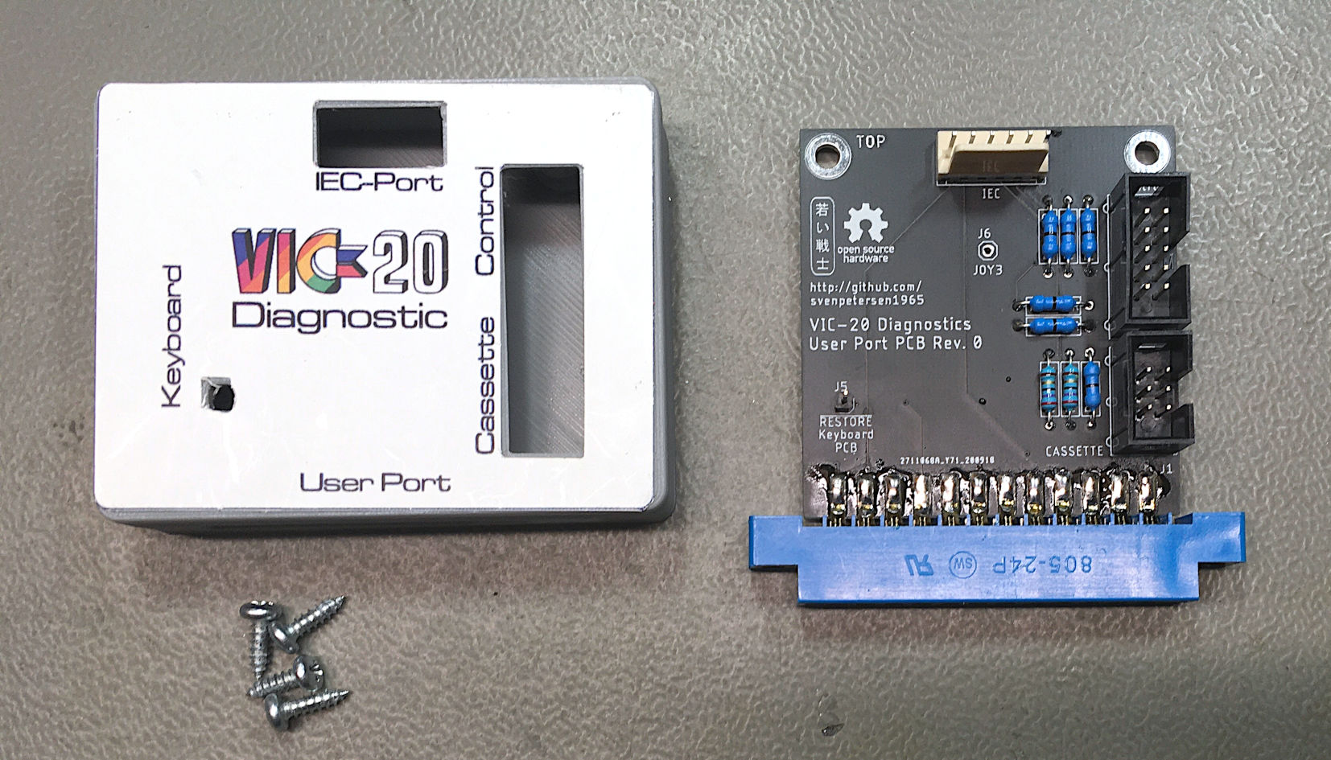

Figure 2: User Port PCB with 3D-printed case

# Revision History

## Rev. 0

* Fully working prototype

## Rev. 1

* 0Ω resistors replaced with closed solder bridges to reduce part count
* Cool new logo
* Not yet tested, but low risk modification. Ready for production.